Name: **MovieSelectorGUI**

Description: **Chapter 13 – Programming Exercise 3**

**Select a movie and view starting and running times**

Write a C# GUI application that contains a ListBox with the titles of five movie titles shown below. When the user places the mouse over the ListBox, display a Label that contains directions for the user to follow and a Label that contains starting time for all the movies. The directions the user is to follow must appear in red font color. Both Labels disappear when the mouse leaves the ListBox area. When the user selects (clicks) a movie title in the ListBox, display another Label that displays the selected movie’s running time. Design your GUI as shown.

Movie Titles Running Time

The Amazing Spider-Man 2 Hours 22 Minutes

The Other Woman 1 Hour 50 Minutes

Brick Mansions 1 Hour 30 Minutes

Heaven Is for Real 1 Hour 40 Minutes

Rio 2 1 Hour 45 Minutes

Under the opening brace for public partial class Form1: Form – declare a string array and populate it with the movie running times.

Create a Mouse Hover event method for the Movies ListBox. Within the method, appropriately use (.Enabled) equals true and (.Visible) equals true on the “starting times” label to display its contents. Appropriately use (.Enabled) equals true and (.Visible) equals true on the “select a movie” label to display its contents. Items in each label are to appear as shown.

Create a Mouse Leave event method for the Movies ListBox. Within the method, clear the display label that displays the running time for the selected movie. Appropriately use (.Visible) equals false to hide the “starting times” label. Appropriately use (.Visible) equals false to hide the “select a movie” label. Deselect the selected movie by making the ListBox’s (.SelectedIndex) equal to -1.

Create a Selected Index Changed event method for the Movies ListBox. Within the method, use an if statement to determine if the first movie in the ListBox was selected using (.GetSelected(0)). Within the body of the if statement, display the running time “running time” message for the move using the array and subscript 0. Construct similar if statements for the remaining four movies in the ListBox. After the series of if statements, appropriately use (.Visible) equals false to hide the “select a movie” label.

*Note: If you chose not to use a series of five if statements, you can use one for loop to process the items in the list box using (.Items.Count). The body of the for loop will contain one if statement that is similar to the one described above*.

Complete the Pseudocode Template document for this programming request. A printed version is due upon arrival to class on lab day.

Use your completed Pseudocode document to create the C# application. Create and save the application to your classroom USB flash drive.

GUI in the Design Window

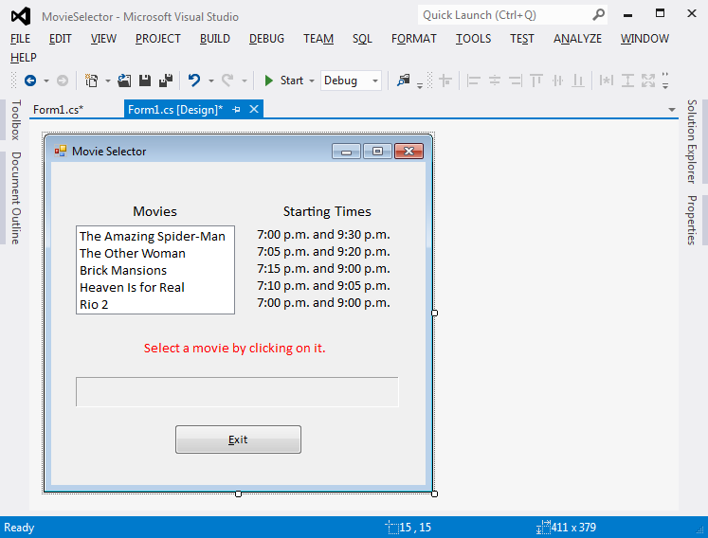

GUI When Started Sample Output (1) – MouseHover ListBox

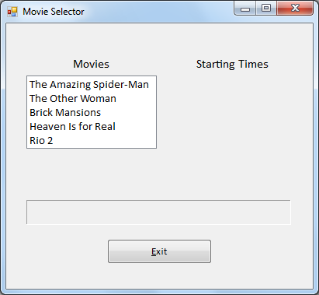 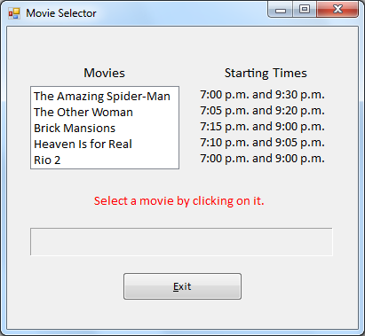

Sample Output (2) – Click on a Movie Sample Output (3) – MouseLeave ListBox

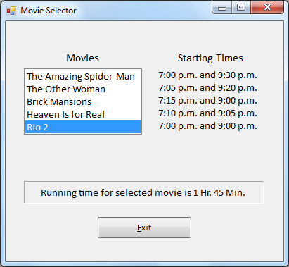 

Sample Output (4) – MouseHover ListBox Sample Output (5) – Click on a Movie

 